**Cross Validation**

Whenever we build any machine learning model, we feed it with initial data to train the model. And then we feed some unknown data (test data) to understand how well the model performs and generalized over unseen data. If the model performs well on the unseen data, it’s consistent and is able to predict with good accuracy on a wide range of input data; then this model is stable.

But this is not the case always! Machine learning models are not always stable and we have to evaluate the stability of the machine learning model. That is where Cross Validation comes into the picture.

In simple terms, Cross-Validation is a technique used to evaluate how well our Machine learning models perform on unseen data.

**Need of Cross-Validation:**

**Case 1:** Suppose you built a machine learning model and use all available data for training and testing on same dataset.

**Problem:** Measuring the score of a model when model has seen all the data is not good. This is same as testing a student out of 100 questions when he has worked on all those 100 questions.

**Case 2:** Split available datset into train and test set.

**Problem:** Out of 100 questions, training has been done on 70 questions and remaining 30 questions are kept for testing the performance of student. Suppose, these 70 questions he has seen is from calculus and remaining 30 questions will be from algebra. In this case, he won’t perform well and leads to overfitting. So, this technique is not very perfect when compared to cross validation.

|  |  |
| --- | --- |
| **Calculus** | **Algebra** |

To overcome over-fitting problems, we use a technique called Cross-Validation.

**Cross-Validation** is a resampling technique with the fundamental idea of splitting the dataset into 2 parts- training data and test data. Train data is used to train the model and the unseen test data is used for prediction. If the model performs well over the test data and gives good accuracy, it means the model hasn’t overfitted the training data and can be used for prediction.

Let’s dive deep and learn about some of the model evaluation techniques.

**1. Hold Out method:**

This is the simplest evaluation method and is widely used in Machine Learning projects. Here the entire dataset(population) is divided into 2 sets – train set and test set. The data can be divided into 70-30 or 60-40, 75-25 or 80-20, or even 50-50 depending on the use case. As a rule, the proportion of training data has to be larger than the test data.

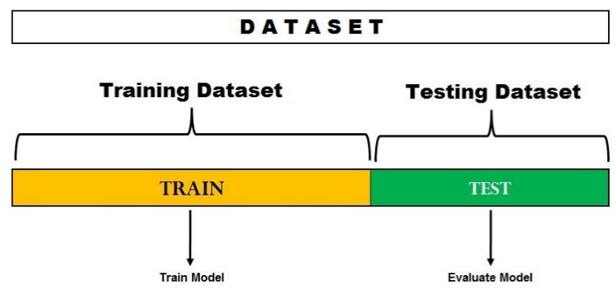

The data split happens randomly, and we can’t be sure which data ends up in the train and test bucket during the split unless we specify random_state. This can lead to extremely high variance and every time, the split changes, the accuracy will also change.

## 2. Leave One Out Cross-Validation:

## In this method, we divide the data into train and test sets – but with a twist. Instead of dividing the data into 2 subsets, we select a single observation as test data, and everything else is labeled as training data and the model is trained. Now the 2nd observation is selected as test data and the model is trained on the remaining data.

## Leave One Out Cross-Validation

This process continues ‘n’ times and the average of all these iterations is calculated and estimated as the test set error.

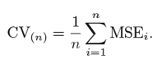

When it comes to test-error estimates, LOOCV gives unbiased estimates (**low bias**). But bias is not the only matter of concern in estimation problems. We should also consider variance.

LOOCV has an extremely **high variance** because we are averaging the output of n-models which are fitted on an almost identical set of observations, and their outputs are highly positively correlated with each other. And you can clearly see this is computationally expensive as the model is run ‘n’ times to test every observation in the data.

Quick implementation of Leave One Out Cross-Validation in Python:

from sklearn.model_selection import LeaveOneOut

X = [10,20,30,40,50,60,70,80,90,100]

l = LeaveOneOut()

for train, test in l.split(X):

print("%s %s"% (train,test))

Output

[1 2 3 4 5 6 7 8 9] [0]

[0 2 3 4 5 6 7 8 9] [1]

[0 1 3 4 5 6 7 8 9] [2]

[0 1 2 4 5 6 7 8 9] [3]

[0 1 2 3 5 6 7 8 9] [4]

[0 1 2 3 4 6 7 8 9] [5]

[0 1 2 3 4 5 7 8 9] [6]

[0 1 2 3 4 5 6 8 9] [7]

[0 1 2 3 4 5 6 7 9] [8]

[0 1 2 3 4 5 6 7 8] [9]

This output clearly shows how LOOCV keeps one observation aside as test data and all the other observations go to train data.

**3. K- Fold cross validation:**

In this resampling technique, the whole data is divided into k sets of almost equal sizes. The first set is selected as the test set and the model is trained on the remaining k-1 sets. The test error rate is then calculated after fitting the model to the test data. In the second iteration, the 2nd set is selected as a test set and the remaining k-1 sets are used to train the data and the error is calculated. This process continues for all the k sets.

The mean of errors from all the iterations is calculated as the CV test error estimate.

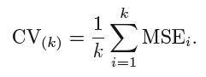

In K-Fold CV, the no of folds k is less than the number of observations in the data (k<n) and we are averaging the outputs of k fitted models that are somewhat less correlated with each other since the overlap between the training sets in each model is smaller. This leads to **low variance** then LOOCV.

The best part about this method is each data point gets to be in the test set exactly once and gets to be part of the training set k-1 times. As the number of folds k increases, the variance also decreases (low variance). This method leads to **intermediate bias** because each training set contains fewer observations (k-1)n/k than the Leave One Out method but more than the Hold Out method.

Typically, K-fold Cross Validation is performed using k=5 or k=10 as these values have been empirically shown to yield test error estimates that neither have high bias nor high variance.

The major disadvantage of this method is that the model has to be run from scratch k-times and is computationally expensive than the Hold Out method but better than the Leave One Out method.

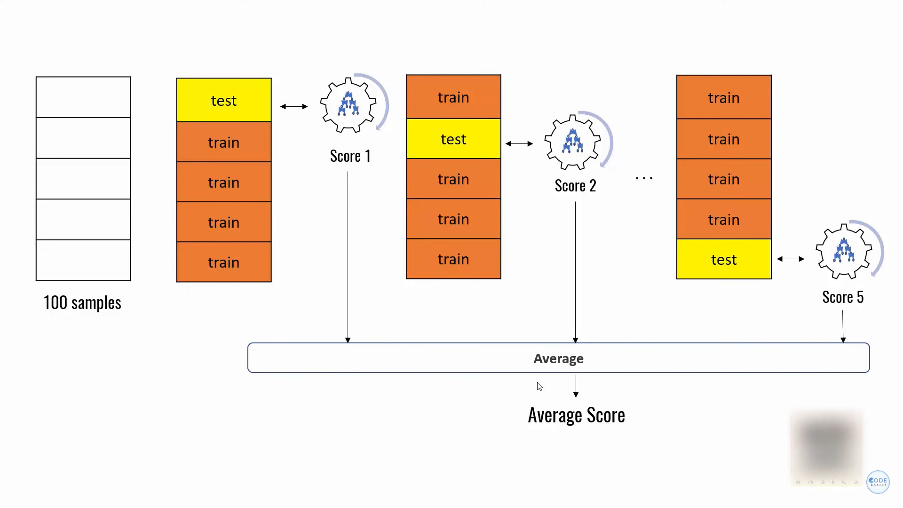

Simple implementation of K-Fold Cross-Validation in Python:

from sklearn.model_selection import KFold

X = ["a",'b','c','d','e','f']

kf = KFold(n_splits=3, shuffle=False, random_state=None)

for train, test in kf.split(X):

print("Train data",train,"Test data",test)

Output

Train: [2 3 4 5] Test: [0 1]

Train: [0 1 4 5] Test: [2 3]

Train: [0 1 2 3] Test: [4 5]

**4. Stratified K fold cross validation:**

This is a slight variation from K-Fold Cross Validation, which uses **‘stratified sampling’** instead of ‘random sampling.’

Let’s quickly understand what stratified sampling is and how is it different from random sampling.

Suppose your data contains reviews for a cosmetic product used by both the male and female population. When we perform random sampling to split the data into train and test sets, there is a possibility that most of the data representing males is not represented in training data but might end up in test data. When we train the model on sample training data that is not a correct representation of the actual population, the model will not predict the test data with good accuracy.

This is where Stratified Sampling comes to the rescue. Here the data is split in such a way that it represents all the classes from the population.

Let’s consider the above example which has a cosmetic product review of 1000 customers out of which 60% is female and 40% is male. I want to split the data into train and test data in proportion (80:20). 80% of 1000 customers will be 800 which will be chosen in such a way that there are 480 reviews associated with the female population and 320 representing the male population. In a similar fashion, 20% of 1000 customers will be chosen for the test data (with the same female and male representation).

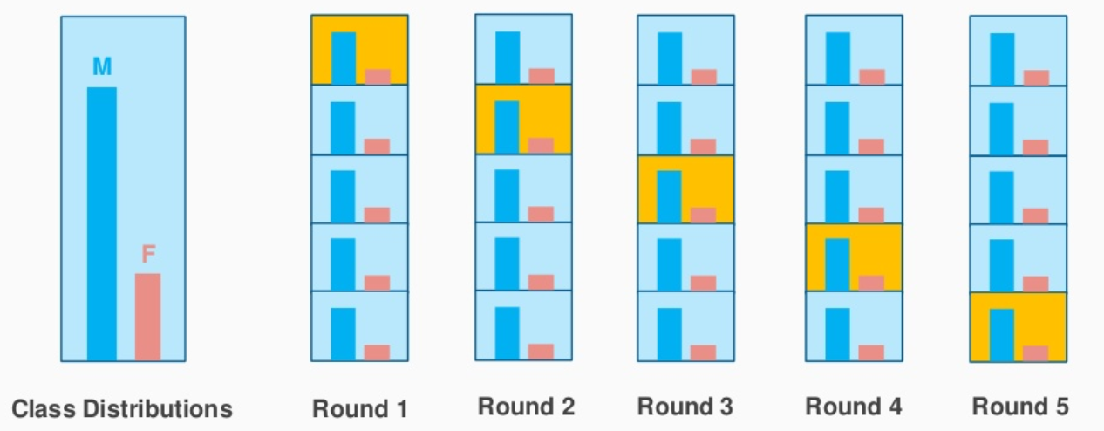

Image Source: stackexchange.com

This is exactly what stratified K-Fold CV does and it will create K-Folds by preserving the percentage of sample for each class. This solves the problem of random sampling associated with Hold out and K-Fold methods.

Quick implementation of Stratified K-Fold Cross-Validation in Python:

from sklearn.model_selection import StratifiedKFold

X = np.array([[1,2],[3,4],[5,6],[7,8],[9,10],[11,12]])

y= np.array([0,0,1,0,1,1])

skf = StratifiedKFold(n_splits=3,random_state=None,shuffle=False)

for train_index,test_index in skf.split(X,y):

print("Train:",train_index,'Test:',test_index)

X_train,X_test = X[train_index], X[test_index]

y_train,y_test = y[train_index], y[test_index]

Output

Train: [1 3 4 5] Test: [0 2]

Train: [0 2 3 5] Test: [1 4]

Train: [0 1 2 4] Test: [3 5]

The output clearly shows the stratified split done based on the classes ‘0’ and ‘1’ in ‘y’.

**NOTE: sklearn.model_selection** has a method **cross_val_score** which simplifies the process of cross-validation. Instead of iterating through the complete data using the ‘split’ function, we can use *cross_val_score* and check the accuracy score for the chosen cross-validation method.

## cross_val_score function:

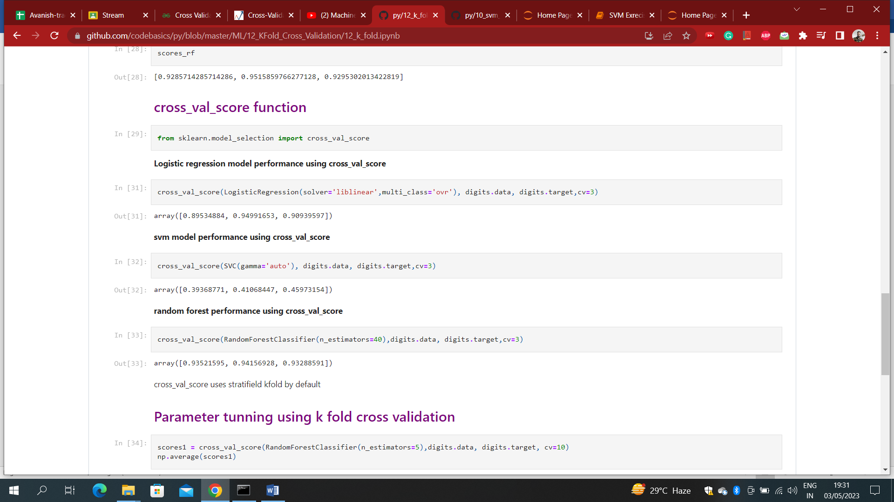

## Bias – Variance Tradeoff:

When we consider the test error rate estimates, K-Fold Cross Validation gives more accurate estimates than Leave One Out Cross-Validation. Whereas Hold One Out CV method usually leads to overestimates of the test error rate, because in this approach, only a portion of the data is used to train the machine learning model.

When it comes to bias, the Leave One Out Method gives unbiased estimates because each training set contains n-1 observations (which is pretty much all of the data). K-Fold CV leads to an intermediate level of bias depending on the number of k-folds when compared to LOOCV but it’s much lower when compared to the Hold Out Method.

To conclude, the Cross-Validation technique that we choose highly depends on the use case and bias-variance trade-off.